**Year 9 Ecology Revision**

**Life Processes**

There are seven characteristics that all living things have in common. They are:

**M**___________________________

**R**___________________________

**S**___________________________

**G**___________________________

**R**___________________________

**E**___________________________

**N**___________________________

**Ecology Terminology**

1. Define the following terms

|  |  |
| --- | --- |
| Term | Definition |
| Abiotic |  |
| Biotic |  |
| Organism |  |
| Ecosystem |  |
| Producer |  |
| Consumer |  |
| Decomposer |  |
| Herbivore |  |
| Carnivore |  |
| Omnivore |  |

**Abiotic Factors**

1. List six abiotic factors and explain how each impacts living organisms

**Food Chains**

1. Complete the following word clozes with words from the boxes above each.

* **Producers – the beginning of the food chain**

producers, photosynthesis, energy, Sun, trees, grass

Plants such as _________________ and _________________ are at the   
bottom of the food chain. They get their _________________ from the  
_________________ and are called _________________ because they produce their own food via the process known as _________________.

* **First order consumers – herbivores**

deer, consumers, herbivores, mice, plants

Animals such as _________________ and _________________ are first   
order_________________ because they get their energy from eating  
_________________. These animals are known as _________________  
because they eat or consume herbs and plants.

* **Second and third order consumers – carnivores**

owls, carnivores, predators, prey, foxes

Animals such as _________________ and _________________ are   
second and third order consumers because they eat animals.   
They are _________________. They are the _________________  
that _________________ on smaller animals.

* **The food chain**

Sun, consumers, chain, web

We can trace the path of energy from the _________________ to producers then first order _________________ then second and third order consumers. They all link together to form a food _________________. Most animals have a variety of organisms in their diet, so they belong to several food chains. All the food chains in a particular ecosystem make up a complex matrix called a food _________________.

1. Complete the food chain for the organisms pictured by writing their names in the correct boxes in the chain below.

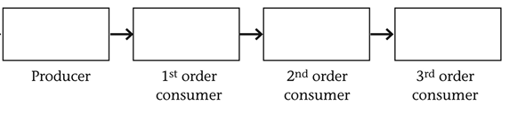

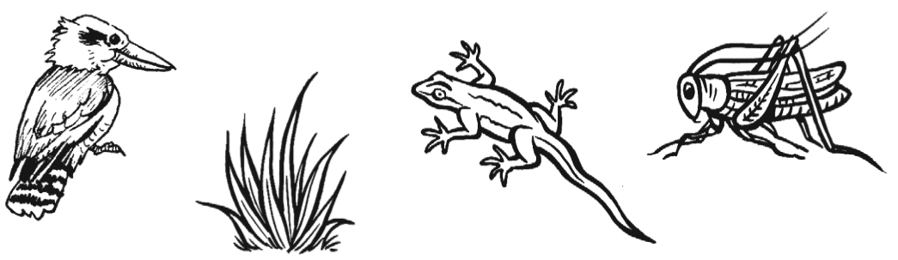

1. Identify three possible food chains from the picture below.

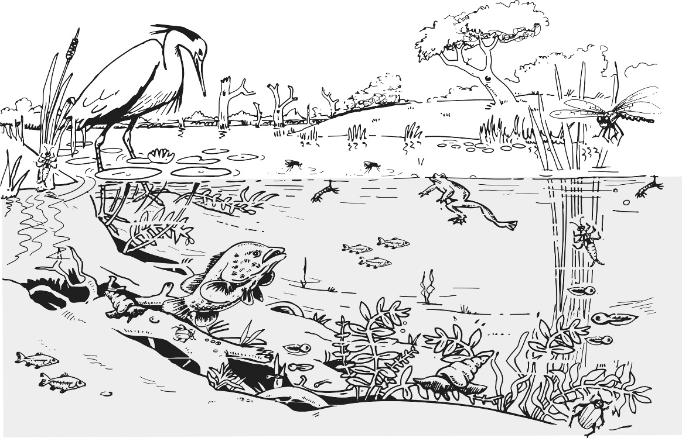

1. Decomposers are very important in food chains and food webs. What is their role?

**Ecological Relationships**

1. Complete the following table to give a definition and an example of each of the ecological relationships.

|  |  |  |
| --- | --- | --- |
| Ecological Relationships | Definition | Example |
| Competition |  |  |
| Predation |  |  |
| Mutualism |  |  |
| Commensalism |  |  |
| Parasitism |  |  |

**Energy Transfer**

1. The following diagram shows a flow chart of how energy is transferred in an ecosystem. Correctly label the empty boxes with the missing terms.   
   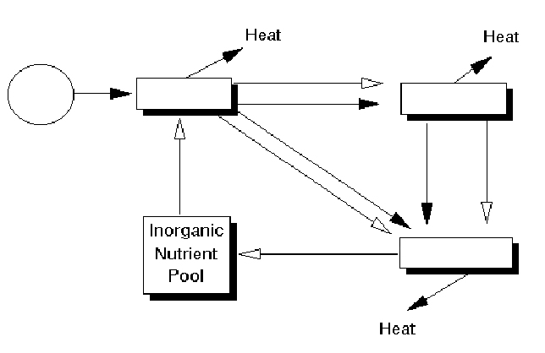
2. Name and complete the word equation for the process by which:

a) Producers make their own food using sun energy.

Name: ________________________

Carbon dioxide + $\underset{→}{light energy}$____________ _____________ + _____________

b) Consumers obtain energy from food they eat.

Name: ________________________

____________ + glucose __________________ + _____________ + energy

1. What is the percentage of energy that can be moved along a food chain from one organism to the next? What happens to the rest of the energy?
2. Fill in the boxes in the Pyramid of Energy using the words below.

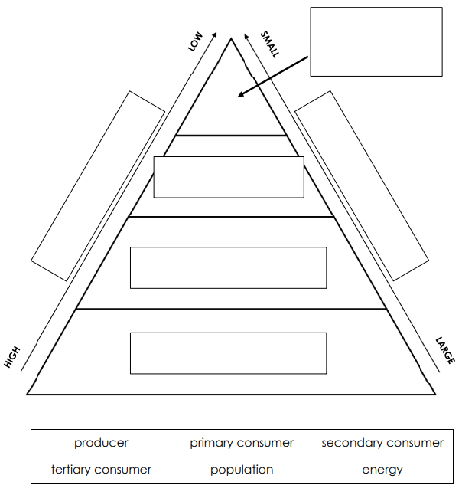

1. Complete the diagram of the carbon cycle below by writing the terms from below in the correct box.

|  |  |  |  |  |
| --- | --- | --- | --- | --- |
| Respiration | Decay | Combustion | Photosynthesis | Fossil Fuels |

